RICOH Process Director - Procedures
Originator: | David Jan |  | Effective Date: | September 07, 2024
Manager Approval: | Sender De La Roca |  | Original Date: | September 07, 2024
 |  |  | Revision Date: | January 15,2025
PURPOSE
Purpose: This software is to automate and manage print workflow for precision. It accepts post scripts, PDF, and AFP formats and transforms into AFP.
PROCEDURES

RICOH RPD (RICOH Process Director Print Workflow Software)
Logon:
https://vpn.best.lacoe.edu/
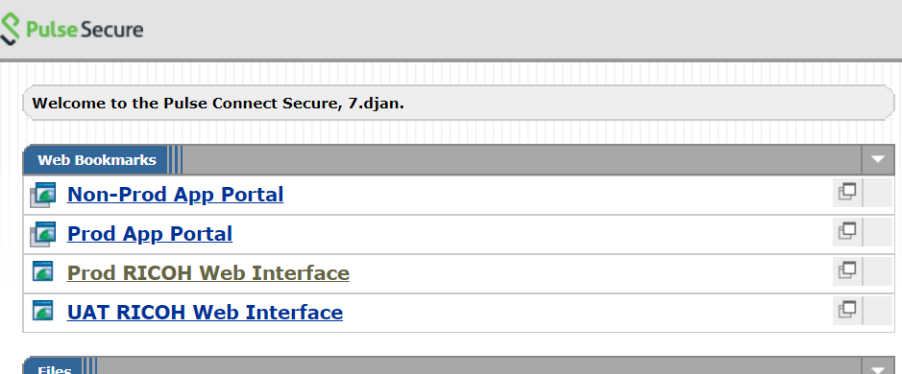
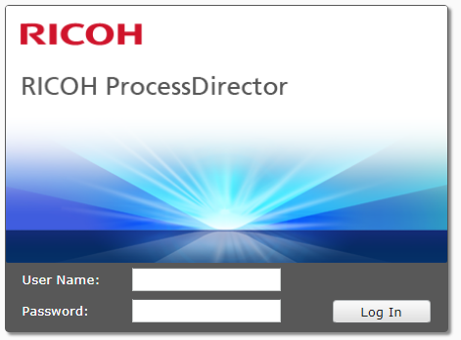

User Name:
Password:

RICOH Main Menu:
For administrator:
There are four menu tabs
- Main
- Administration
- Preferences
- Workflow

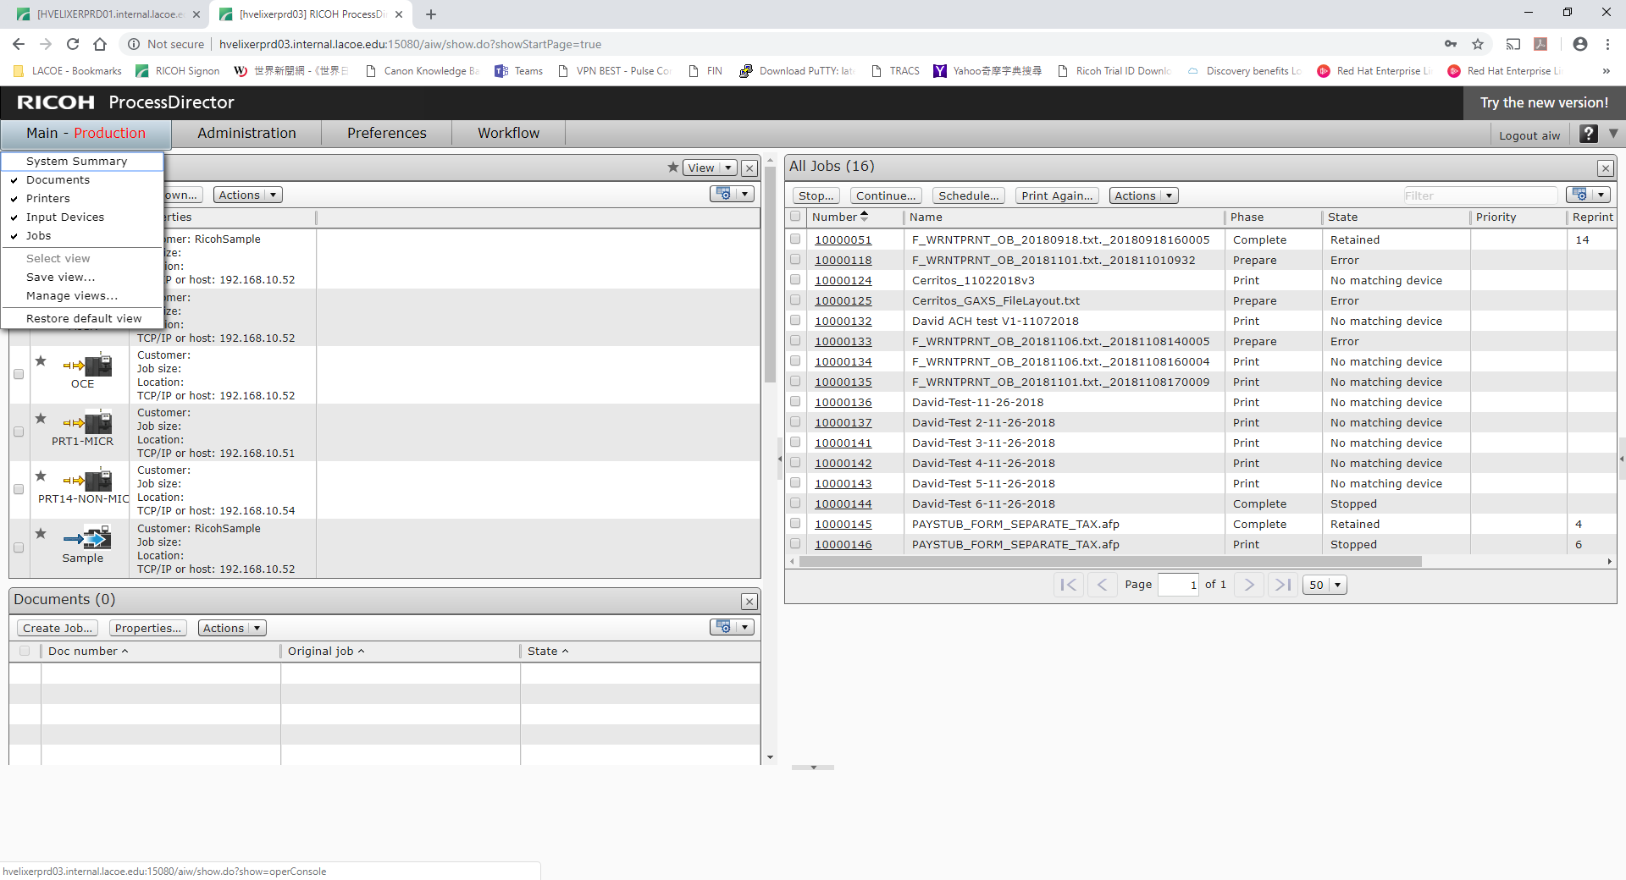

For Operators:

User Name:
Password:

There are only two menu tabs
- Main
- Preferences - (a) change password (b) change time display format
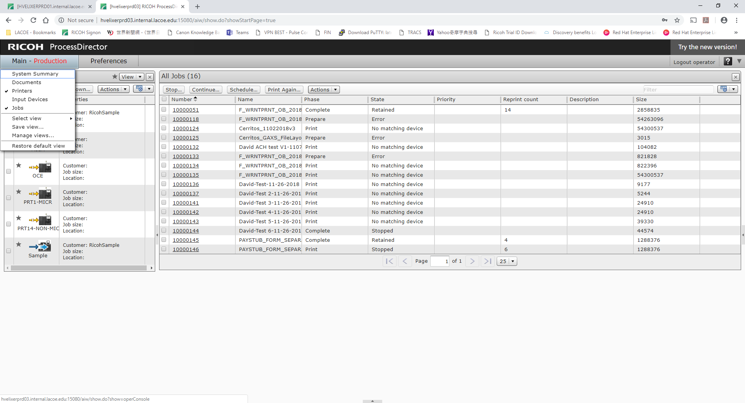

Menu:
- Printer
On top left side shows all printers that we setup.
- Solid arrow line shows the printer is connected, broken dash lines mean the printer is disabled
- All automate RICOH printing jobs are not printed instantly even printer is active. This allow Operator has control to load paper, etc…
On right side shows all print jobs in queue history.
Job cannot be viewed and printed if status has “Error”

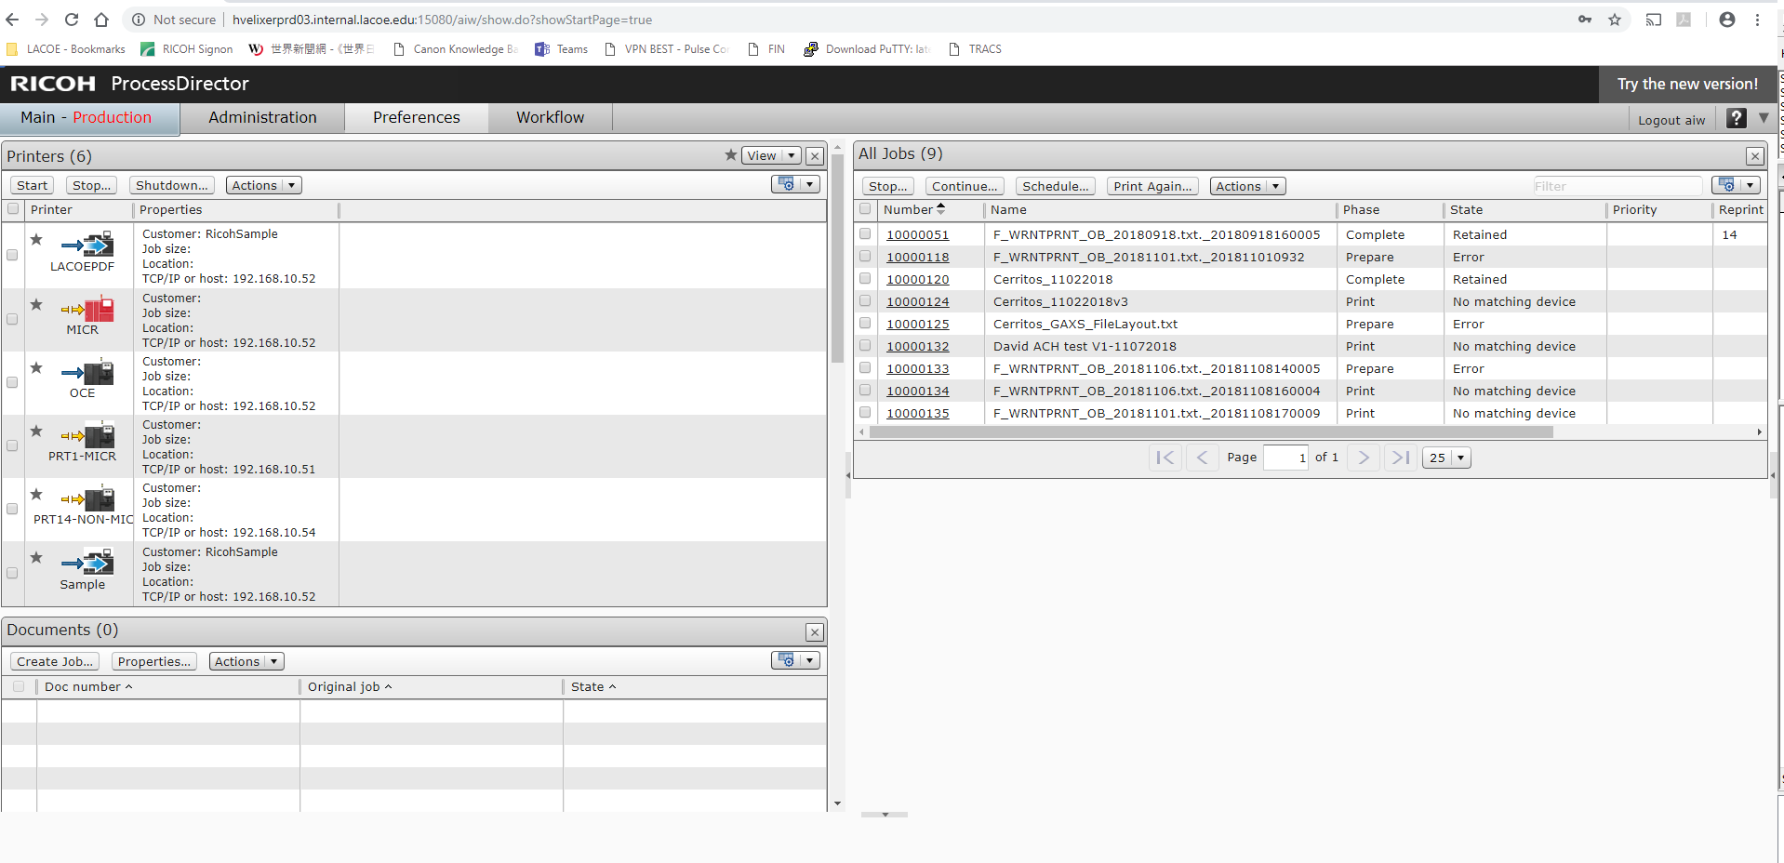
Reprint:
Locate a job number to be printed, highlight and select
- Right click and select “print again”
or
- Click “Print Again” button on top
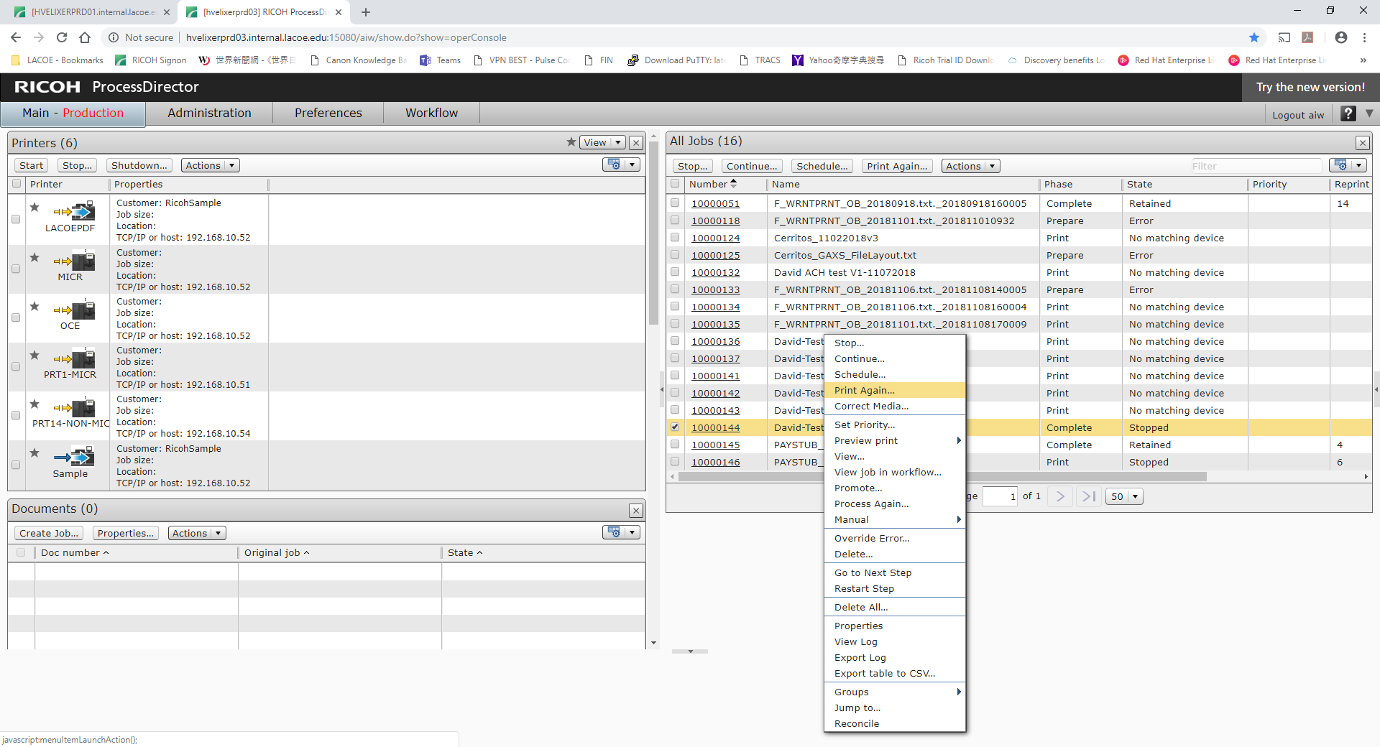

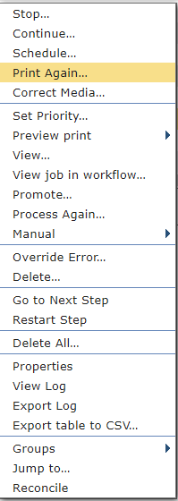
Or
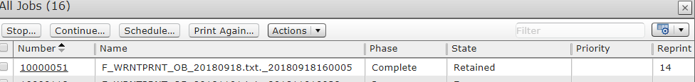

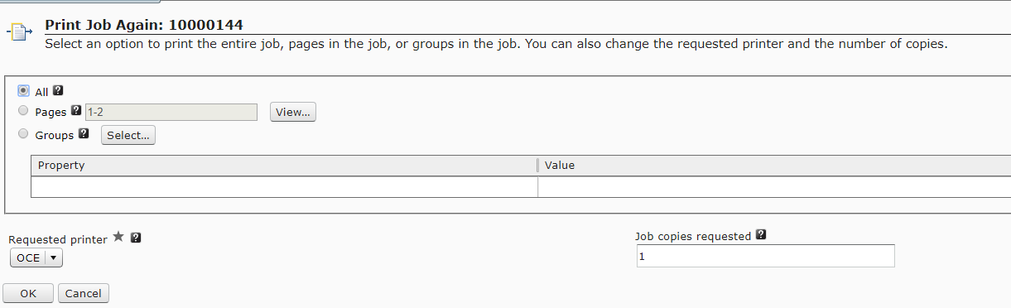
To print all pages – click “All”
To print selected pages – click “Page”, and enter 1, 1-10 etc.
Requested Printer:
OCE – Printer 2, main Micr printer
PRT1-MICR – Printer 1, backup of OCE printer
PRT14-NON-MICR – non MICR printer for test print purpose
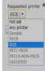

Input Data:

- CGI Advantage creates Bwarrant check/ACH data file via Batch Cycle
- CGI Advantage scripts FTP data (push) to MVS folder: best/NonProd/RICOH/From_BEST/FIN (non production)
best/Prod/RICOH/From_BEST/FIN (production)
- FIN Control-M script SFTP pull data from (2) to RICOH folder:
/aiw/aiw1/System/hf/bestfin (for FIN)
/aiw/aiw1/System/hf/advxform (for HCM)
RICOH View/Print:
- Print job will be placed in job queue, the latest job will be shown at bottom
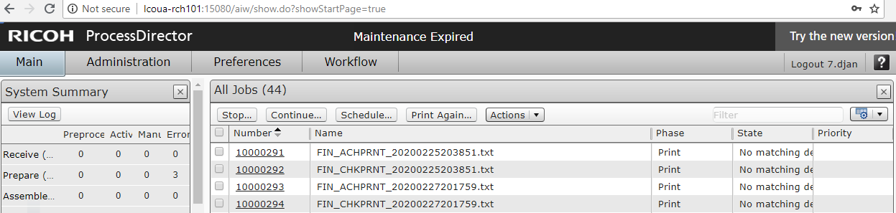

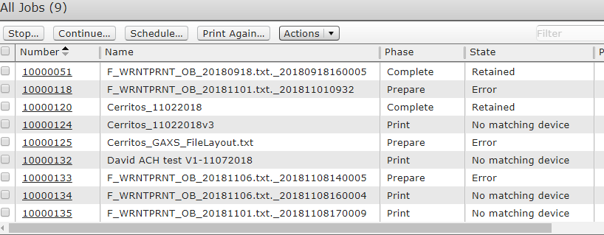
- If you see “Error” from State column, then either input data format has issue or other Elixir related issues
- If Phase column = “Print” and State column = “no matching device” that means check/ACH images are ready for viewing. Once images are acceptable then proceed to reprint step

- View Check image before print (only status has no error)
Highlight, right click and select “View”, make 70% to see whole check/ACH image
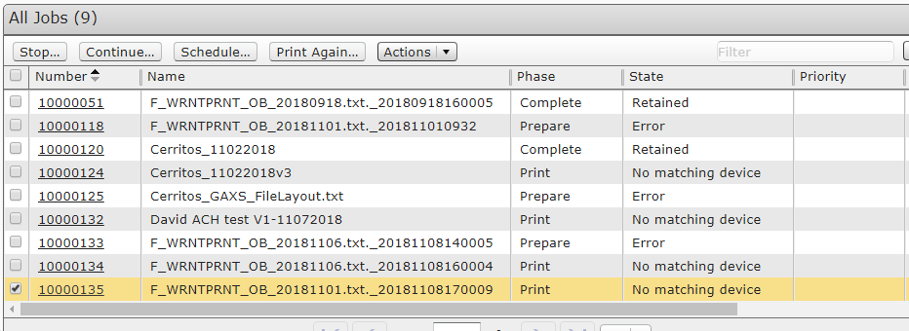

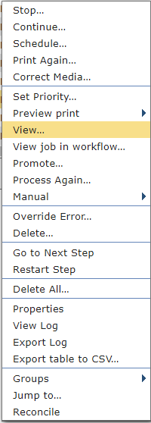

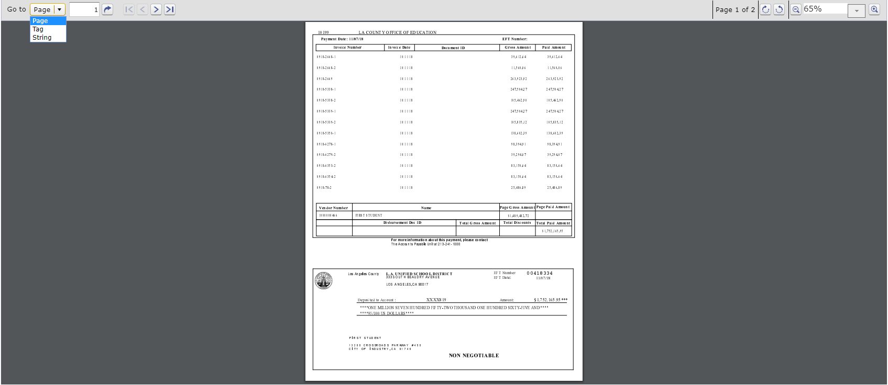

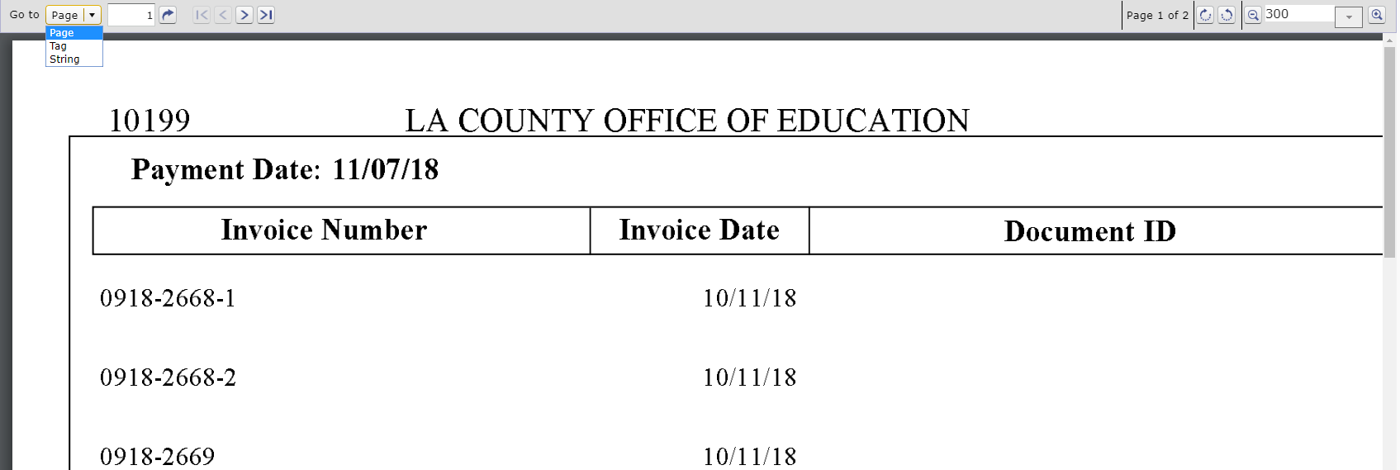

On Top left: Go to drop down box
Page: enter page number
Tag:
String: search string, for example: “Invoice date”

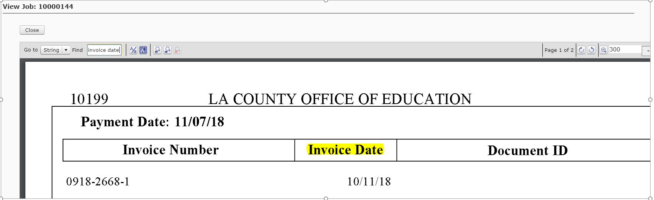
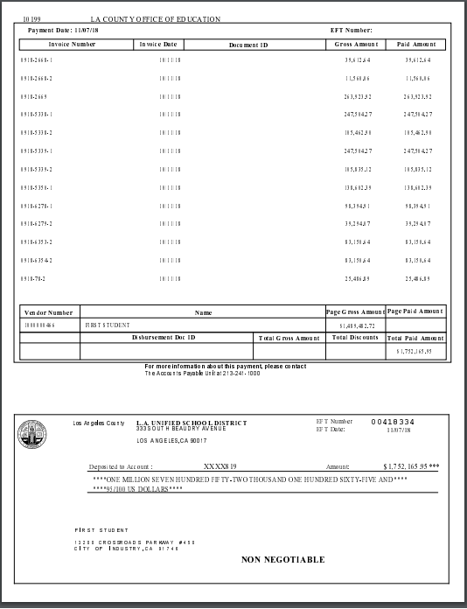

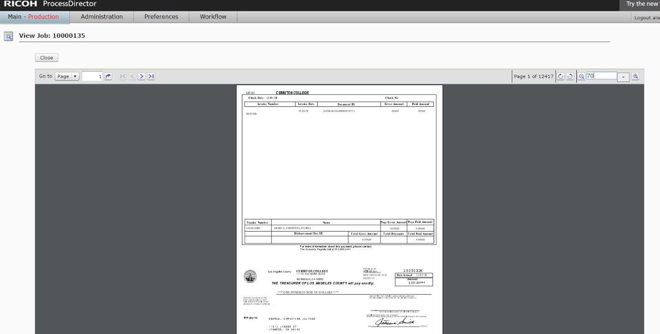

- Highlight and click “Print Again” button on top (Or right click and select “print again”)
- Select Print page ranges and requested printer:
Before:

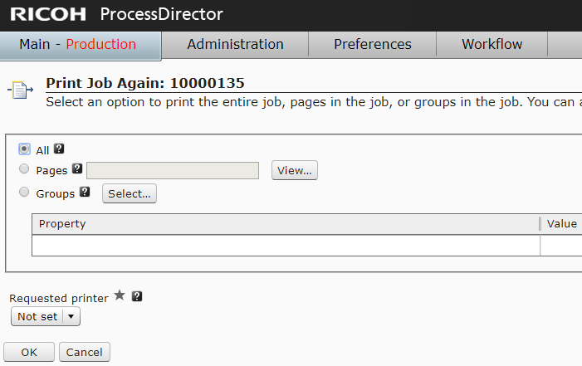

After:

All: all pages
Pages: 1-20,15,20-25

Requested printer:
OCE: Micr Printer (printer 2 located at warrant room, need Citibank verifies Micr line),
PRT14-NON-MICR (Printer 14, non-Micr printer located at outside warrant room, mainly for testing purpose, printed at white plain papers)

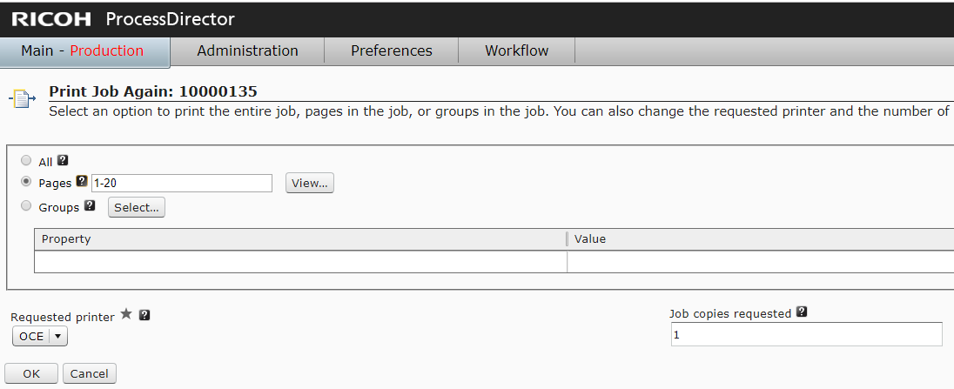

Before print job, please call Operator: Sender DeLaRoca (x 6028) or Dave (x 6529) make sure printer is on.

Print Job executing sequences are Print -> Queue -> Spool -> printing -> Retained

If job is never being retained, then there is something problem with printing. See troubleshooting.

Troubleshooting:

Highlights job queue – select, right click, and select ‘View Log”

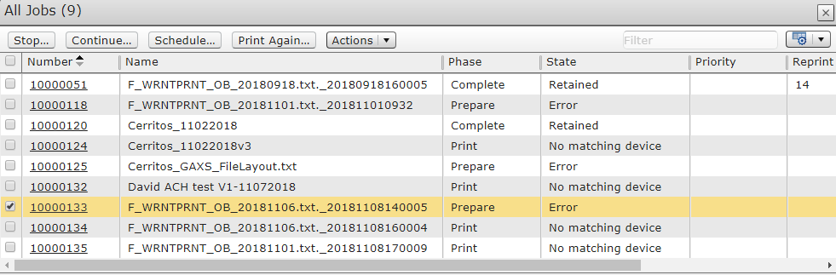

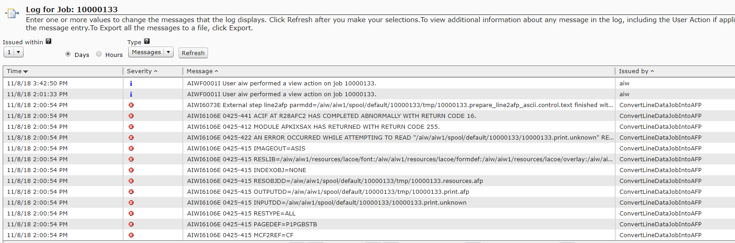

Severity: red color is a show stopper, blue color is acceptable
Issued By: workflow step caused error

Each print job is driven by workflow

Work Flow:

- Bwarrant: bestfin

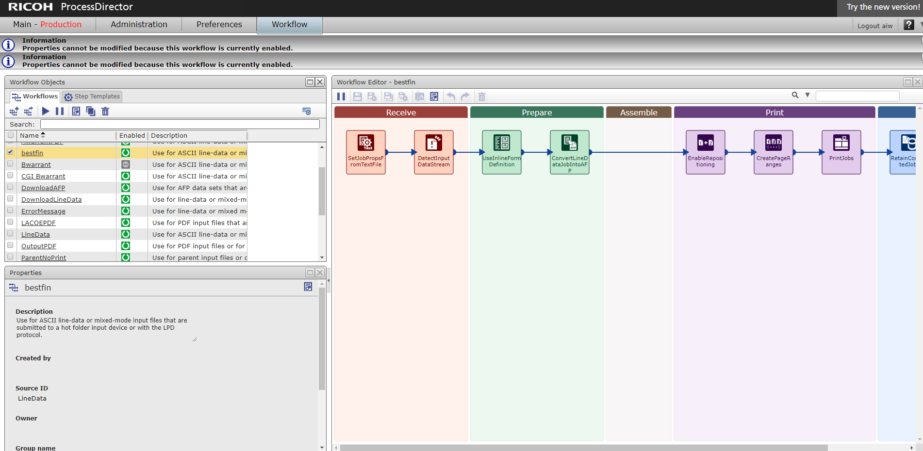

Receive:

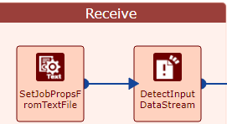

Steps:
SetJobPropsFromTextfile

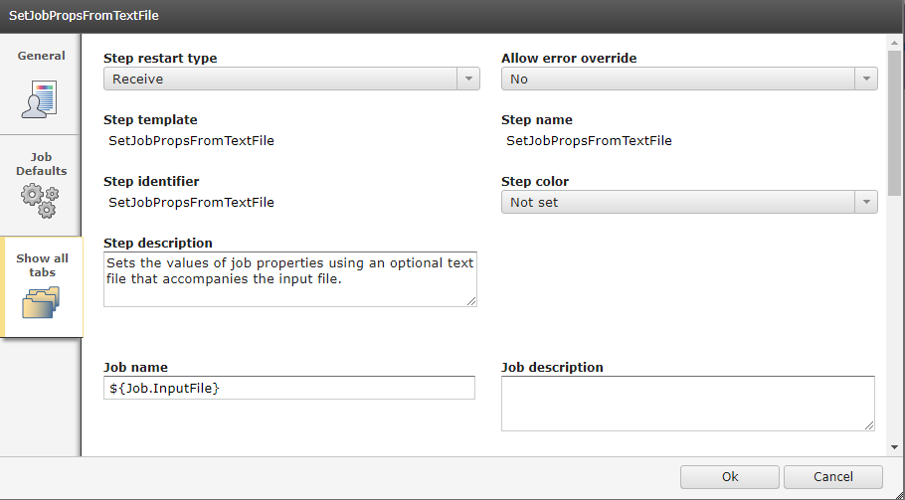
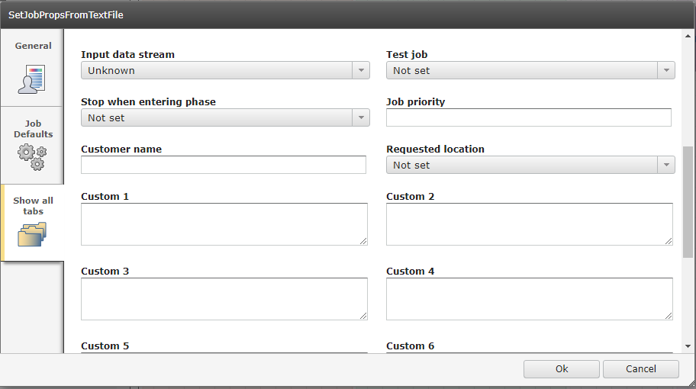

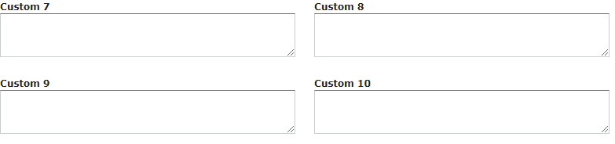

DetectInputDataStream

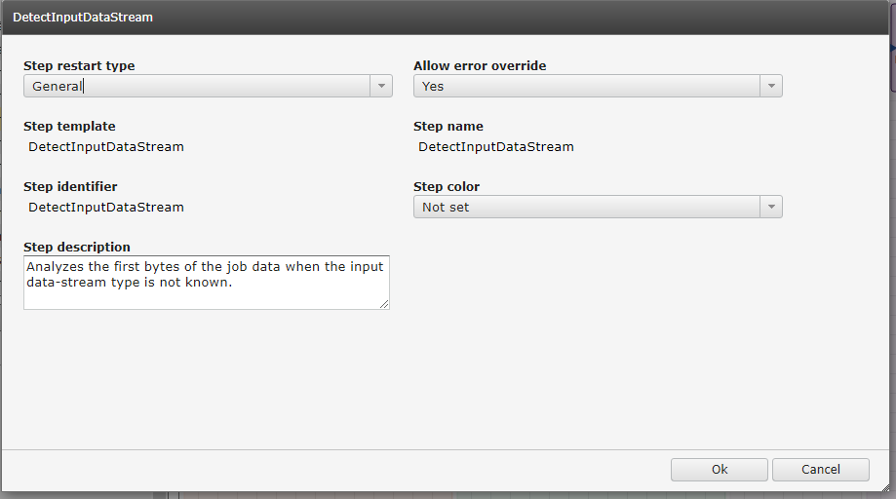

Prepare:

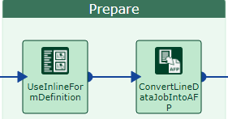

- UseInlineFromDefenition
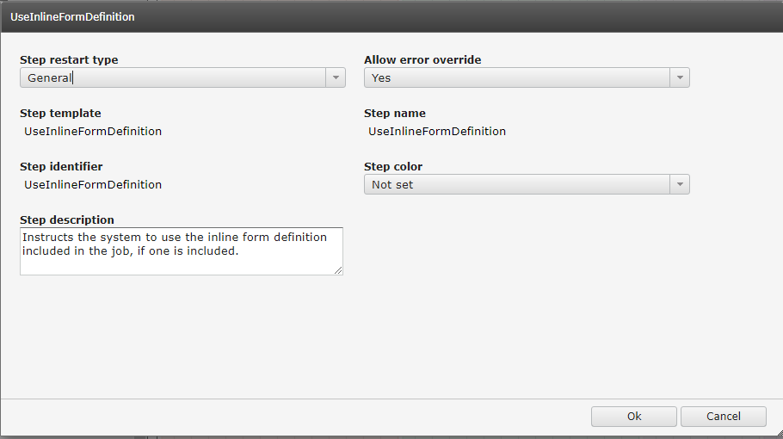

- ConvertLineDatajobIntoAFP

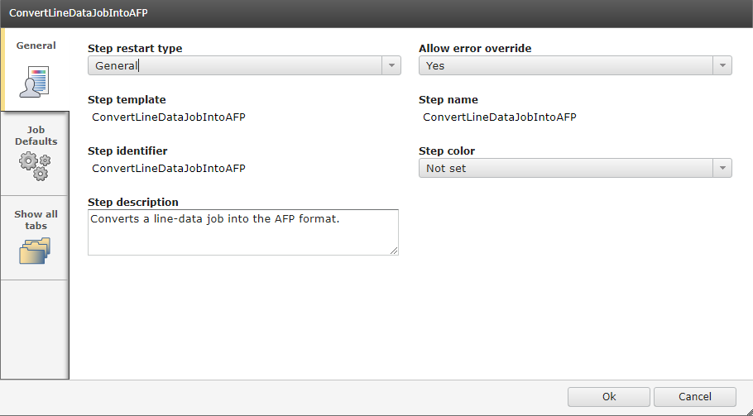
Assemble:

None

Print:

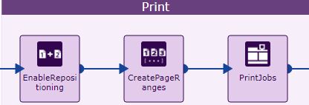

EnableRepositioning

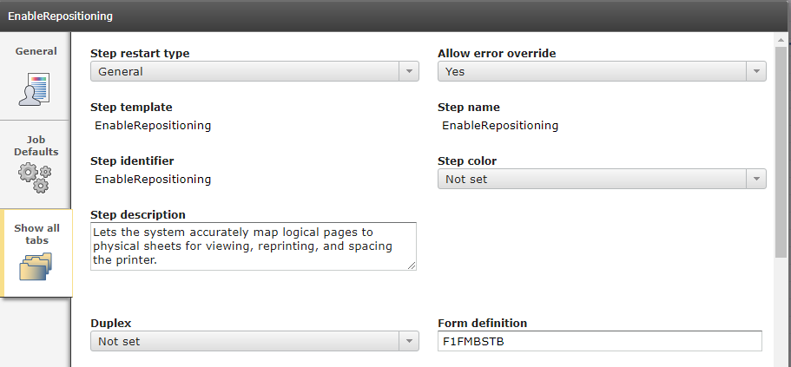

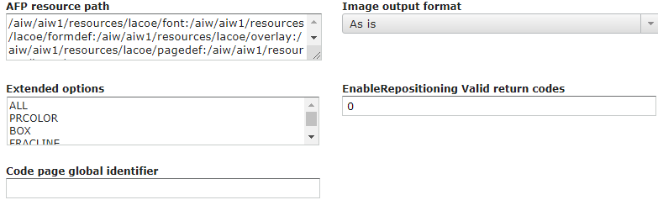

AFP resource path:

/aiw/aiw1/resources/lacoe/font:/aiw/aiw1/resources/lacoe/formdef:/aiw/aiw1/resources/lacoe/overlay:/aiw/aiw1/resources/lacoe/pagedef:/aiw/aiw1/resources/lacoe/seg

CreatePageRanges

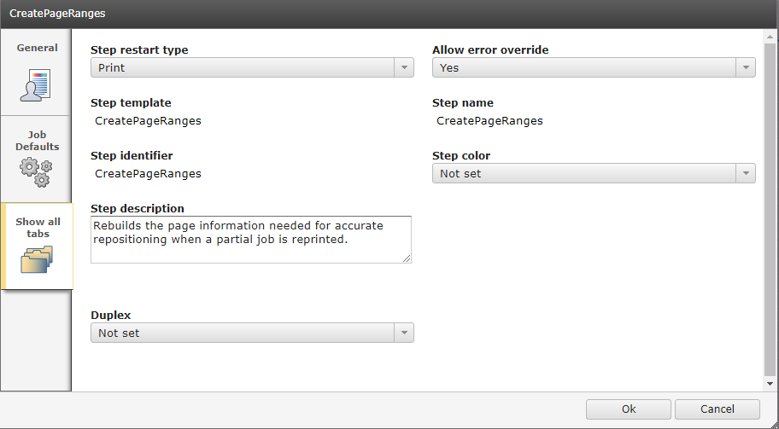

PrintJobs

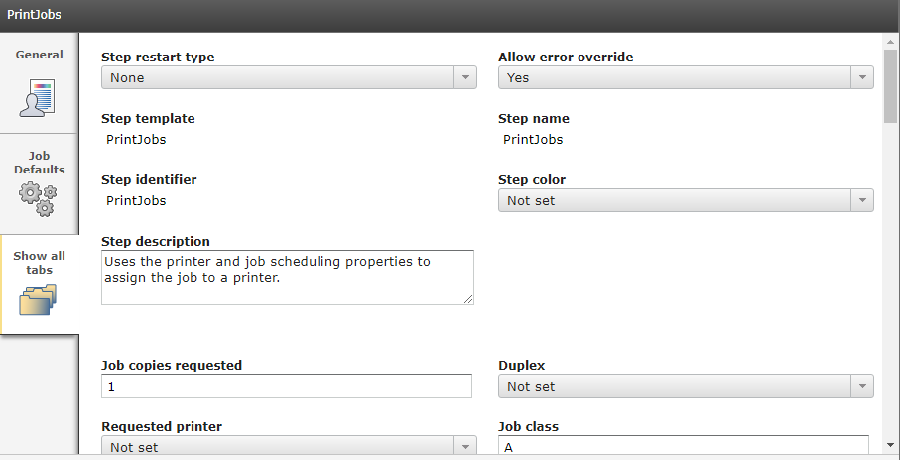

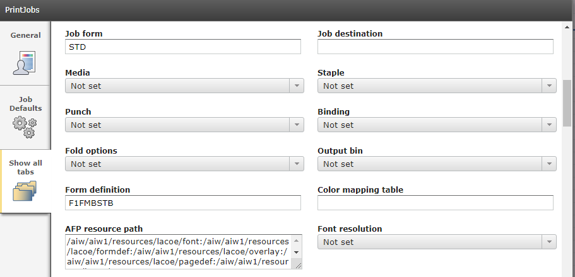

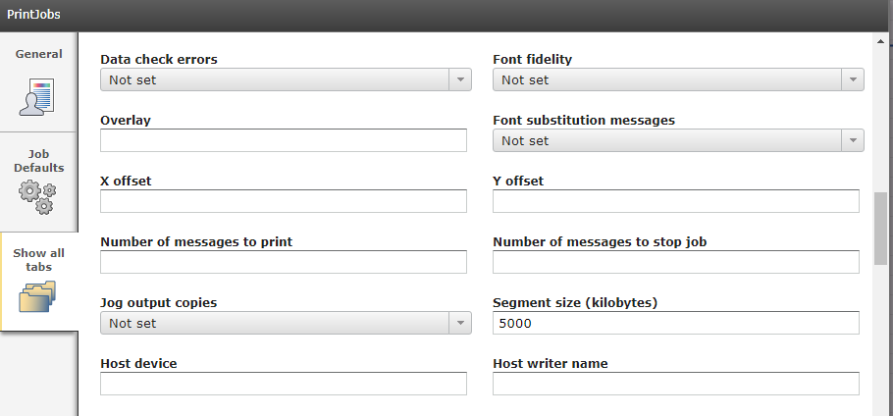

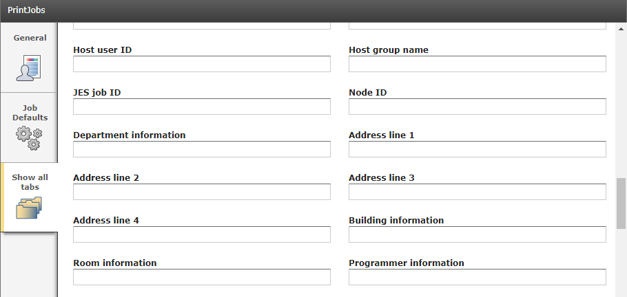

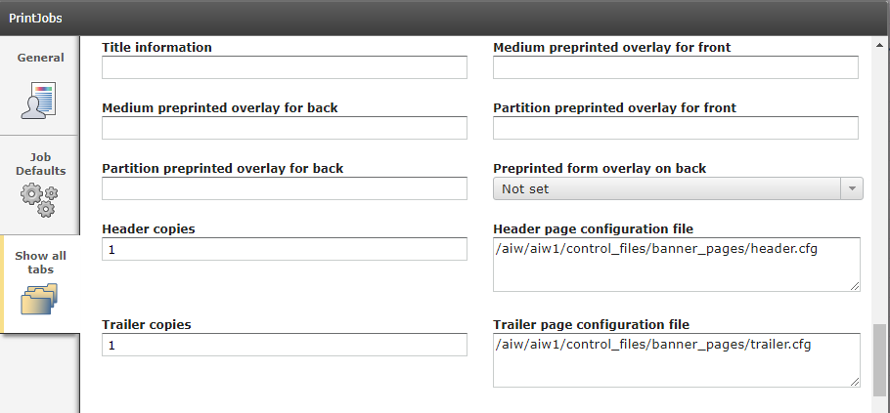

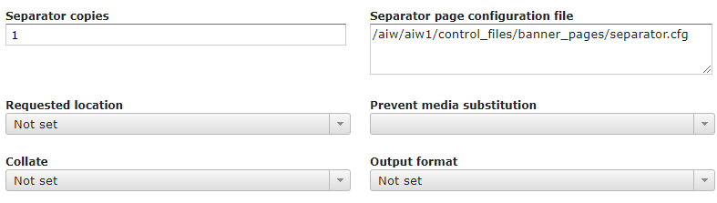

Complete:

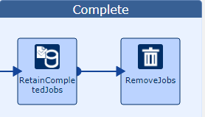

RetainCompletedJobs

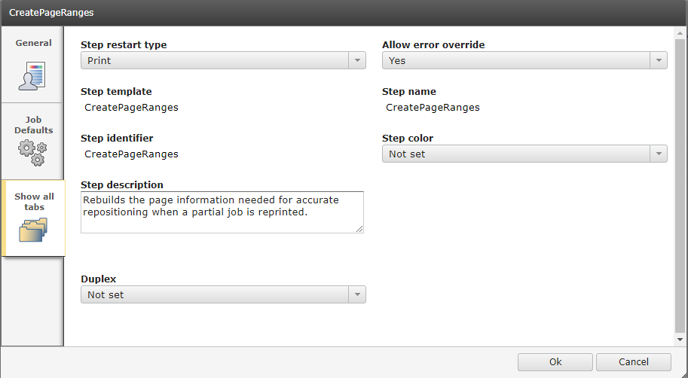

RemoveJobs

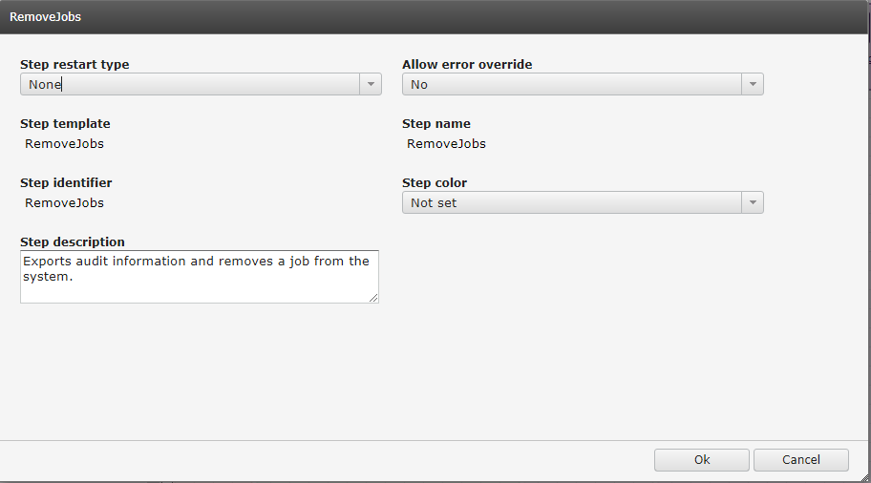

- Awarrant: advxform
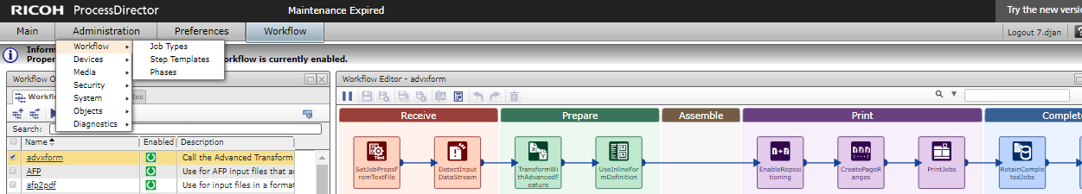

FileZilla:

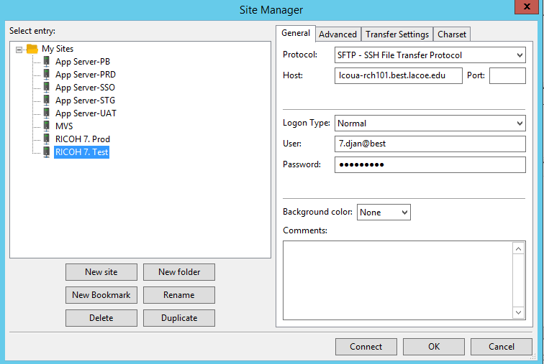

Export/Import Objects:

Under Administration -> Object -> Export/Import
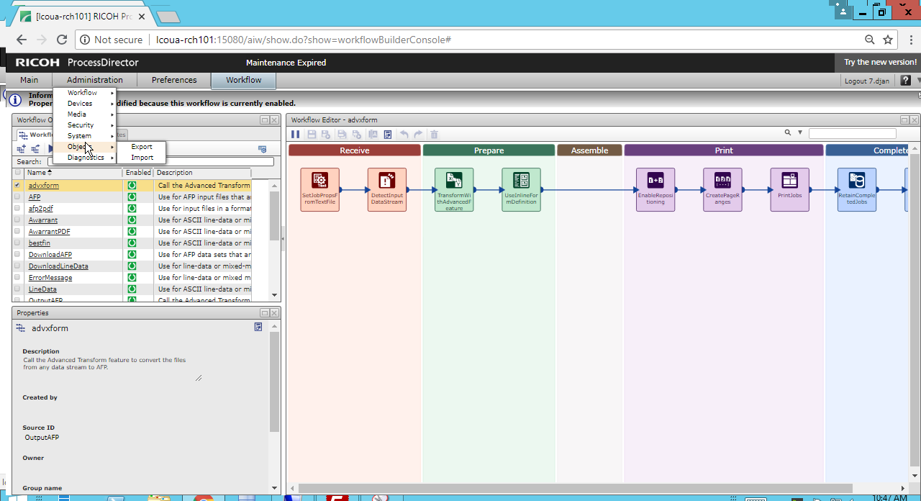

You purchased input-pdf and output-afp advanced transform. The print-ready afp file will be in the spool dir.
/aiw/aiw1/spool/default/0000xxx/0000xxx.print.afp
You can grab that afp file and give it to your vendor for testing.

